HEALTH SCOPE – A Full-Lifecycle Public Health Analytics & Risk Dashboard
A Project Report Submitted in
the partial fulfillment of the requirements for the award of the degree of
BACHELOR OF TECHNOLOGY
In
DEPARTMENT OF COMPUTER SCIENCE AND ENGINEERING
By
Siril Punna | : 2420030300
D. Dinesh Kumar | : 2420030169
D. Srivatsav Reddy | : 2420030320
Under the Esteemed Guidance of
Dr. N. Sunanda
Associate Professor
Department of Computer Science and Engineering
Course: Data Science (24AD3107) | Batch No: 20
AY – 2026-2027
Semester: V



K L (Deemed to be) University
DEPARTMENT OF COMPUTER SCIENCE AND ENGINEERING
Declaration
The Project Report entitled “HEALTH SCOPE – A Full-Lifecycle Public Health Analytics & Risk Dashboard” is a record of Bonafide work of Siril Punna – 2420030300, D. Dinesh Kumar – 2420030169, D. Srivatsav Reddy – 2420030320 submitted in partial fulfillment for the award of B.Tech in Computer Science and Engineering to the K L (Deemed to be) University. The results embodied in this report have not been copied from any other departments/University/Institute.

Siril Punna – 2420030300
D. Dinesh Kumar – 2420030169
D. Srivatsav Reddy – 2420030320

K L (Deemed to be) University
DEPARTMENT OF COMPUTER SCIENCE AND ENGINEERING
CERTIFICATE
This is to certify that the project based report entitled “HEALTH SCOPE – A Full-Lifecycle Public Health Analytics & Risk Dashboard” is a bonafide work done and submitted by Siril Punna – 2420030300, D. Dinesh Kumar – 2420030169, D. Srivatsav Reddy – 2420030320 in partial fulfillment of the requirements for the award of the degree of BACHELOR OF TECHNOLOGY in Department of Computer Science and Engineering, K L (Deemed to be University), during the academic year 2026-2027.

_____________________  Signature of the Guide  Dr. N. Sunanda  Associate Professor, CSE | _____________________  Course Coordinator  Dr. N. Sunanda  Department of CSE | _____________________  Head of the Department  Dr.P. Venkateswara Rao  Department of CSE

ACKNOWLEDGEMENT
The success of this project would not have been possible without the timely help and guidance rendered by many people. We wish to express our sincere thanks to all those who assisted us in one way or the other in the completion of our project.
Our greatest appreciation goes to our Course Coordinator and our guide Dr. N. Sunanda, Assistant Professor, Department of Computer Science and Engineering, whose tremendous support, encouragement and guidance cannot be expressed in words.
We express our gratitude to Dr.P. Venkateswara Rao, Head of the Department of Computer Science and Engineering, for providing us with adequate facilities, ways and means by which we were able to complete this project.
We thank all the members of the teaching and non-teaching staff, and all those who have assisted us directly or indirectly in the successful completion of this project. Finally, we sincerely thank our parents, friends and classmates for their kind help and cooperation during our work.

Siril Punna – 2420030300
D. Dinesh Kumar – 2420030169
D. Srivatsav Reddy – 2420030320

ABSTRACT
Health Scope is a full-lifecycle public health analytics and risk-prediction system designed to analyse healthcare and demographic data and generate meaningful, data-driven insights. The project addresses the challenges involved in processing and understanding large healthcare datasets by providing an integrated pipeline for data collection, preprocessing, analysis, machine learning and visualisation.
The system collects health-related data from publicly available datasets such as the National Family Health Survey (NFHS), hospital admission datasets or suitable disease-specific datasets. The collected data undergoes data ingestion, cleaning, missing-value handling, duplicate detection, outlier analysis, exploratory data analysis and feature engineering. Machine-learning algorithms – Logistic Regression, Decision Tree, Random Forest, K-Nearest Neighbours and Naïve Bayes – are trained and compared to identify the most suitable model for health-risk prediction.
The system provides an interactive dashboard for exploring health trends, demographic patterns, risk factors and model performance. Users can analyse important health indicators and obtain risk predictions based on the selected input parameters. Model performance is evaluated using accuracy, precision, recall, F1-score and the confusion matrix.
Health Scope demonstrates how data engineering, data analytics, machine learning and interactive visualisation can be integrated into a single end-to-end platform for public health analysis. The system helps to identify significant health patterns and risk factors and presents them in an accessible form to support data-driven analysis and decision-making.
Keywords: public health analytics, NFHS, data preprocessing, exploratory data analysis, machine learning, risk prediction, Streamlit dashboard.

INDEX
S.No. | Chapters | Topics | Page no.
 |  | Acknowledgement | i
 |  | Abstract | ii
 |  | Index, List of Figures, List of Tables | iii
1 | Introduction | 1.1 Background of the project  1.2 Problem statement  1.3 Scope of the project  1.4 Objectives  1.5 Importance of the application  1.6 Target users / audience  1.7 Literature survey  1.8 Research gap and proposed solution | 1-5
2 | System Requirements | 2.1 Hardware requirements  2.2 Software requirements  2.3 Development tools and frameworks  2.4 Functional and non-functional requirements | 6-7
3 | Technology Stack | 3.1 Front-end (Streamlit, Plotly)  3.2 Back-end (Python, Pandas, Scikit-learn)  3.3 Data storage  3.4 Version control (Git, GitHub)  3.5 APIs or external services | 8-9
4 | System Architecture | 4.1 High-level architecture diagram  4.2 Description of each layer  4.3 Deployment architecture  4.4 Data flow diagrams | 10-12
5 | Design | 5.1 Wireframes or mock-ups  5.2 ER diagram / database schema  5.3 Pipeline flowchart | 13-16
6 | Implementation | 6.1 Module-wise implementation  6.2 Data ingestion and preprocessing  6.3 EDA and feature engineering  6.4 Model building and evaluation  6.5 Dashboard logic (front-end)  6.6 Data connectivity and API integration  6.7 Access control and data privacy | 17-22
7 | Features | 7.1 List of main features  7.2 How each feature works (user perspective + technical description) | 23-24
8 | Testing | 8.1 Functional testing  8.2 Integration testing  8.3 Tools used for testing  8.4 Test cases and results  8.5 Validation method and evaluation framework  8.6 Results and performance comparison | 25-28
9 | Deployment | 9.1 Steps to deploy  9.2 Environment configuration  9.3 Hosting | 29
10 | Challenges & Limitations | 10.1 Issues faced during development  10.2 Solutions applied  10.3 Current limitations or known bugs | 30
11 | Future Enhancements | 11.1 Planned features  11.2 Possible integrations or optimisations  11.3 Real-world applications | 31
12 | Conclusion | 12.1 Summary of the project  12.2 What was achieved  12.3 Skills learned during development | 32-33
13 | References | Books, journals, tutorials, APIs and documentation sites used | 34
14 | Appendices | Screenshots of the application  Sample code snippets  Installation / set-up instructions  User manual or guide  Certifications  Team contribution | 35-37

LIST OF FIGURES
No. | Caption | Page
1.1 | The HealthScope data-science lifecycle | 1
4.1 | High-level architecture of HealthScope | 10
4.2 | DFD Level-0 (context diagram) | 12
4.3 | DFD Level-1 | 12
5.1 | Wireframe – Health Trends Explorer | 13
5.2 | Wireframe – Risk Prediction | 14
5.3 | Wireframe – Model Performance | 14
5.4 | Logical database schema (ER diagram) | 15
5.5 | Flowchart of the data-processing and modelling pipeline | 15
8.1 | Layout of the confusion matrix used for evaluation | 27

LIST OF TABLES
No. | Caption | Page
1.1 | Scope of the project | 2
1.2 | Target users of HealthScope | 3
1.3 | Summary of literature survey | 4
1.4 | Research gap and how HealthScope addresses it | 5
2.1 | Hardware requirements | 6
2.2 | Software requirements | 6
3.1 | Technology stack at a glance | 9
4.1 | Deployment configuration | 11
5.1 | Description of schema entities | 15
6.1 | Modules of HealthScope | 17
6.2 | Candidate data sources | 17
6.3 | Summary of the selected dataset | 17
6.4 | Algorithms used in HealthScope | 20
7.1 | Feature descriptions – user perspective and technical description | 23
8.1 | Test cases | 25
8.2 | Evaluation metrics | 26
8.3 | Performance comparison of the five models | 27
9.1 | Environment configuration | 29
10.1 | Challenges and solutions | 30
11.1 | Planned enhancements | 31
12.1 | Objectives and outcomes | 32
F.1 | Contribution of each team member | 37

CHAPTER 1
Introduction

1.1 Background of the Project
Public health is the science and practice of protecting and improving the health of entire populations. In the last two decades, health systems around the world have begun to generate data at a scale that was unimaginable earlier: national household surveys, hospital admission registers, disease-surveillance reports, laboratory results and, increasingly, readings from wearable devices. This data holds valuable information about which communities are most vulnerable, which risk factors are rising, and where interventions will have the greatest effect.
In India, the National Family Health Survey (NFHS), conducted under the Ministry of Health and Family Welfare with the International Institute for Population Sciences (IIPS) as the nodal agency, is one of the largest sources of such information. It reports demographic, household, nutrition, maternal-child health and non-communicable disease indicators across states and districts over several survey rounds. Hospital admission datasets and disease-specific clinical datasets add complementary detail about diagnoses, patient demographics and outcomes.
Although these datasets are publicly available, converting them into insight is far from trivial. They are large, contain missing and inconsistent values, mix categorical and numerical fields, and are usually published as static tables or reports. Analysts must repeatedly perform the same sequence of steps – collection, cleaning, exploration, modelling and visualisation – using separate tools. HealthScope is designed to bring all these steps together into one reproducible, end-to-end system that follows the complete data-science lifecycle.
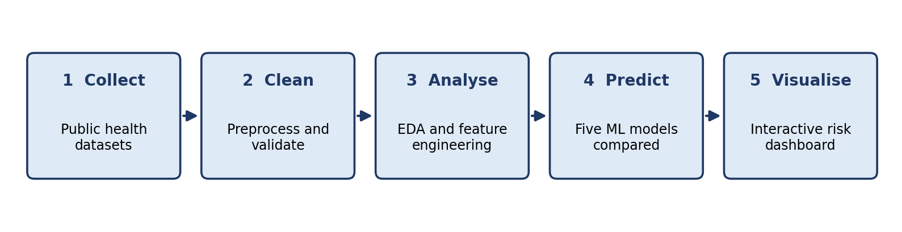
Fig. 1.1 The HealthScope data-science lifecycle
As shown in Fig. 1.1, the lifecycle begins with the collection of public health datasets, followed by cleaning and validation, exploratory analysis and feature engineering, machine-learning based risk prediction using five classifiers, and finally an interactive dashboard through which users can explore trends and obtain risk predictions.

1.2 Problem Statement
Public health data is scattered across several sources and is mostly reported in static form. There is no single platform that allows a user to ingest such data, prepare it for analysis, understand the underlying patterns, compare predictive models and finally explore the results interactively. As a consequence:
- Hospital records, government health surveys and disease-specific datasets remain siloed, so a unified view of population health risk is difficult to obtain.
- Manual and fragmented analysis delays the detection of rising chronic-illness trends and risk factors; risks are often noticed only after significant harm has occurred.
- Most existing public-health portals provide after-the-fact statistical summaries rather than proactive, predictive risk assessment.
- Health officials, researchers and students have no accessible tool that links data preparation, machine-learning comparison and visual exploration in a single workflow.
The problem addressed by this project is therefore to design and implement a full-lifecycle public health analytics and risk-prediction platform that ingests public health data, cleans and analyses it, trains and compares multiple machine-learning models, and presents the outcome through an interactive dashboard.

1.3 Scope of the Project
The scope of the project has been defined carefully so that the work remains achievable within the course duration and yet demonstrates the complete data-science lifecycle.
Table 1.1 Scope of the project
In scope | Out of scope
Public datasets: NFHS, hospital admissions and disease-specific data | Clinical diagnosis or treatment decisions
Full pipeline from ingestion to feature engineering | Live hospital or wearable data streams
Five machine-learning models compared on standard metrics | Deep-learning and big-data (Apache Spark) models
Interactive dashboard with health-risk prediction | Use of personally identifiable patient data

It is important to note that the risk predictions generated by HealthScope are risk indicators for population-level analysis. They are not medical diagnoses and must not be used as a substitute for professional clinical judgement.

1.4 Objectives
The objectives of the project are stated below. Each objective begins with an action verb and can be verified against the delivered system; the extent to which each was achieved is revisited in Chapter 12.
- Design an end-to-end pipeline for data ingestion, cleaning, exploratory data analysis (EDA) and feature engineering of public health data.
- Train and compare five machine-learning models – Logistic Regression, Decision Tree, Random Forest, K-Nearest Neighbours (KNN) and Naïve Bayes – for health-risk prediction.
- Evaluate every model using accuracy, precision, recall, F1-score and the confusion matrix, and identify the most suitable model.
- Develop an interactive dashboard for exploring health trends, demographic patterns, risk factors, model performance and for obtaining risk predictions from user-supplied inputs.

1.5 Importance of the Application
HealthScope is important for several reasons. First, it shortens the distance between raw public data and usable insight by automating the repetitive stages of the data-science workflow. Second, it replaces static reporting with an interactive, explorable view of health indicators across regions and demographic groups. Third, by comparing five different classifiers on identical data splits, it provides evidence-based guidance on which modelling approach is most suitable for health-risk prediction, instead of relying on a single, arbitrarily chosen algorithm.
From an academic perspective the project demonstrates how data engineering, data analytics, machine learning and interactive visualisation – normally taught as separate topics – can be combined into one working platform. From a societal perspective, early identification of risk factors and high-risk population segments supports preventive action, better planning and more efficient allocation of limited health resources.

1.6 Target Users / Audience
Table 1.2 Target users of HealthScope
User group | How they benefit
Health officials and policy planners | Explore regional and demographic health trends; identify high-risk segments to support planning and resource allocation.
Public-health researchers and analysts | Reproduce the full pipeline, compare models and examine feature importance and model performance.
NGOs and community health organisations | Screen communities for early risk indicators and prioritise outreach programmes.
Students and educators | Study an end-to-end data-science project that covers every stage of the lifecycle.

1.7 Literature Survey
A literature survey was carried out to understand how machine learning is currently applied in public health and to identify what is still missing. Four recent studies were examined; they are summarised in Table 1.3.
Table 1.3 Summary of literature survey
S.No | Author(s) & Year | Method / Technique | Key Findings | Limitation / Gap
1 | Wang, Song & Bi (2025) [1] | Random Forest with bootstrap sampling and out-of-bag error on community health survey data of older adults | Strong predictive accuracy; ranked the socio-economic and health factors most strongly linked to community health risk | Single older-adult population; cross-sectional data; no streaming or multi-institution data
2 | Chen & Long (2025) [2] | SVM-based feature elimination selecting 14 predictors from over 26,000 NHIS respondents; nomogram-style risk model | AUC of 0.813 for arthritis risk; age, general health, BMI and comorbidities were leading predictors | One disease, self-reported data; no real-time monitoring
3 | Liu, Krentz, Lu & Curcin (2025) [3] | Systematic review and meta-analysis of 20 studies (ML vs. conventional models) on EHR data for cardiovascular risk | Random Forest and deep-learning models outperformed QRISK3 and ASCVD; pooled AUC up to 0.865 | Variable methods and limited transparency; not validated for real-world deployment
4 | Dhanda et al. (2025) [4] | Narrative review of 170 machine-learning studies in public health | LightGBM, GRU and LSTM reached 88–95% prediction accuracy | Privacy, fairness and institutional readiness remain open; no ingestion-to-dashboard system

Observations. Tree-based ensemble methods such as Random Forest repeatedly perform strongly on health data and offer feature-importance rankings that are valuable for public-health interpretation. Survey and health-record data are the dominant inputs. However, each of the surveyed works concentrates on a single disease or population, or on prediction alone.

1.8 Research Gap and Proposed Solution
The studies reviewed above achieve high accuracy but treat prediction in isolation. None of them describes a complete system that spans data ingestion, cleaning, model comparison and a public-facing dashboard. This is the research gap that HealthScope addresses.
Table 1.4 Research gap and how HealthScope addresses it
Research gap | How HealthScope addresses it
Single-function tools address only prediction, only visualisation, or only a single disease or condition. | Unifies ingestion, cleaning, risk modelling and visualisation across multiple health indicators in one platform.
High accuracy is reported on static, single-population survey datasets. | Built on a reproducible Python pipeline that can be re-run on any compatible public dataset.
Systematic reviews synthesise model performance but are not connected to a dashboard. | Processed data and model outputs flow directly into an interactive dashboard.
Ensemble and deep-learning models are computationally heavy and evaluated on a single dataset. | Five lightweight, interpretable scikit-learn models are compared on identical splits and metrics.
No single reviewed system spans ingestion, risk prediction and decision support. | Full lifecycle: ingestion → cleaning → EDA and features → modelling → dashboard.

The key novelty of the project is the unification of data engineering, analytics, machine learning and interactive visualisation in one end-to-end platform, instead of isolated prediction-only or visualisation-only tools.

CHAPTER 2
System Requirements

2.1 Hardware Requirements
HealthScope is a lightweight data-science application. The datasets used (NFHS extracts, hospital admission tables and disease-specific tables) fit comfortably in the memory of an ordinary laptop, so no specialised hardware such as a GPU is required. The minimum configuration used for development and testing is listed in Table 2.1.
Table 2.1 Hardware requirements
Component | Requirement
Processor | Intel Core i5 or higher (or equivalent AMD Ryzen)
RAM | 8 GB minimum (16 GB recommended for larger datasets and cross-validation)
Storage | 10 GB free disk space for datasets, notebooks, models and virtual environment
Network | Internet connection for downloading datasets, installing packages and using Google Colab
Display | Standard monitor, 1366 × 768 or higher, for viewing the dashboard

2.2 Software Requirements
Table 2.2 Software requirements
Item | Requirement
Operating system | Windows 10 / 11 (also runs on Linux and macOS)
Programming language | Python 3.x
Development environment | Jupyter Notebook / Google Colab
Core libraries | Pandas, NumPy, Scikit-learn
Visualisation libraries | Matplotlib, Seaborn, Plotly
Dashboard framework | Streamlit
Version control | Git and GitHub
Web browser | Any modern browser (Chrome, Edge, Firefox) to view the dashboard

2.3 Development Tools and Frameworks
The tools below were used across the development lifecycle:
- Jupyter Notebook / Google Colab – interactive environment for data exploration, experimentation and model training. Colab provides a free, shareable runtime that requires no local set-up.
- Python virtual environment (venv) – isolates project dependencies so that the pipeline can be reproduced on another machine.
- Git and GitHub – version control, collaboration among the three team members and storage of the final code repository.
- Streamlit – open-source Python framework used to convert the analysis into an interactive web dashboard without writing HTML, CSS or JavaScript.
- Visual Studio Code / Jupyter – editor used for writing modules and the dashboard script.

2.4 Functional and Non-Functional Requirements

2.4.1 Functional requirements
- The system shall load public health datasets in CSV format and display their schema and summary statistics.
- The system shall detect and treat missing values, duplicate records and outliers.
- The system shall encode categorical fields, scale numerical fields and generate engineered features.
- The system shall train five classification models on an identical train–test split and report accuracy, precision, recall, F1-score and confusion matrix for each.
- The system shall allow the user to filter indicators by region and demographic group and view the resulting charts.
- The system shall accept health parameters from the user and return a predicted risk class.

2.4.2 Non-functional requirements
- Reproducibility – a fixed random seed and a common preprocessing pipeline ensure the same results on every run.
- Usability – the dashboard must be understandable to non-technical users, with clear labels and a short disclaimer that predictions are not diagnoses.
- Performance – model prediction for a single user input must return within a few seconds on the minimum hardware configuration.
- Maintainability – the code is divided into independent modules so that a new dataset, model or chart can be added with minimal change.
- Privacy – only publicly available, anonymised datasets are used; no personally identifiable information is stored.

CHAPTER 3
Technology Stack
This chapter describes the technologies chosen for HealthScope. Because HealthScope is a data-science project rather than a conventional web application, the classic front-end / back-end / database layers of the report template have been mapped to their data-science equivalents: a dashboard layer, a Python processing and modelling layer, and a data-storage layer.

3.1 Front-end (Dashboard Layer)
The user-facing part of HealthScope is an interactive dashboard built with Streamlit and Plotly.
- Streamlit turns a Python script into a web application. Widgets such as select boxes, sliders and number inputs collect the user’s choices, and the page re-renders automatically whenever an input changes.
- Plotly produces interactive charts – line charts, bar charts, heatmaps and box plots – with hover tooltips, zooming and filtering.
- Matplotlib and Seaborn are used during analysis in the notebooks for static EDA plots such as histograms, correlation heatmaps and box plots.

3.2 Back-end (Processing and Modelling Layer)
All data processing and machine learning is written in Python 3.
- Pandas – loading, merging, cleaning and transforming tabular data using DataFrames.
- NumPy – numerical operations, array handling and statistics.
- Scikit-learn – preprocessing utilities (imputers, encoders, scalers), the five classifiers, train–test splitting, cross-validation and evaluation metrics. Its Pipeline and ColumnTransformer classes ensure that exactly the same transformations are applied during training and prediction.
- Joblib – saving the trained best model to disk so that the dashboard can load it without retraining.

3.3 Data Storage
For the scope of this project the datasets are stored as CSV files in a structured project folder (raw, interim and processed sub-folders). The processed dataset, the trained model file and the model-metrics table are saved after each pipeline run, so that the dashboard simply reads them. Section 5.2 presents the logical schema of the stored data. For larger deployments, the same schema can be moved to a relational database such as PostgreSQL and a data lake, as discussed in Chapter 11.

3.4 Version Control
Git and GitHub were used for version control. Each team member worked on their own module in a separate branch and merged into the main branch after review. The repository also stores the notebooks, the dashboard script, the dependency file (requirements.txt) and the project documentation.

3.5 APIs and External Services
- NFHS data portal (IIPS) – source of survey data and state/district fact sheets.
- Open government and international data portals (for example data.gov.in and WHO data services) – optional sources for hospital and disease-specific datasets.
- Google Colab – cloud notebook runtime used for experimentation and for team members without a powerful local machine.
- GitHub – hosting of the source code and project links.
Table 3.1 Technology stack at a glance
Layer | Technology | Purpose
Language | Python 3 | Entire pipeline, modelling and dashboard
Data handling | Pandas, NumPy | Ingestion, cleaning, transformation
Machine learning | Scikit-learn, Joblib | Five classifiers, evaluation, model persistence
Visualisation | Matplotlib, Seaborn, Plotly | EDA plots and interactive charts
Dashboard | Streamlit | Interactive web interface and risk prediction
Environment | Jupyter, Google Colab, venv | Development and experimentation
Collaboration | Git, GitHub | Version control and code hosting

CHAPTER 4
System Architecture

4.1 High-Level Architecture Diagram
HealthScope follows a layered architecture in which data moves in one direction – from public data sources, through processing and modelling, to the dashboard. Each layer has a clearly defined responsibility and communicates with the next through well-defined files or objects, which makes the system easy to test and extend.
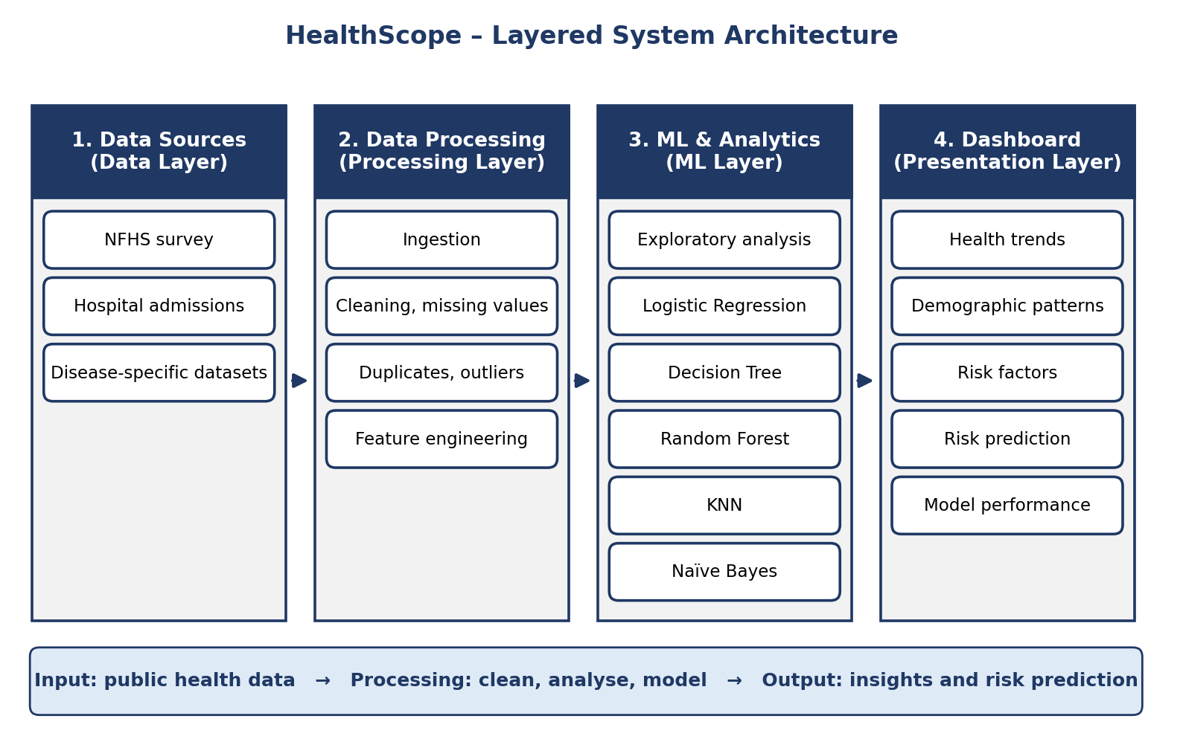
Fig. 4.1 High-level architecture of HealthScope

4.2 Description of Each Layer

4.2.1 Data Layer
The data layer collects health-related data from three candidate source types: the National Family Health Survey (NFHS), hospital admission datasets and disease-specific datasets. Datasets are downloaded from their public portals and stored unchanged in the raw-data folder so that the original source is always preserved.

4.2.2 Processing Layer
The processing layer performs data ingestion and all preparation steps: validation of the schema, handling of missing values, removal of duplicate records, detection and treatment of outliers, encoding of categorical variables, scaling of numerical variables and feature engineering. The output is a clean, model-ready dataset stored in the processed-data folder.

4.2.3 Machine-Learning and Analytics Layer
This layer first carries out exploratory data analysis to understand distributions, correlations and demographic patterns. It then trains the five classifiers – Logistic Regression, Decision Tree, Random Forest, KNN and Naïve Bayes – on the same stratified 80/20 split, evaluates each of them with five metrics, and selects the best model. The selected model and the metrics table are saved for use by the dashboard.

4.2.4 Dashboard (Presentation) Layer
The dashboard layer reads the processed data, the saved model and the metrics. It offers three main views: the Health Trends Explorer, the Risk Prediction page and the Model Performance page. Users interact only with this layer; they never need to run any code.

4.3 Deployment Architecture
HealthScope is deployed in a simple local configuration suitable for an academic project: the Python environment, the processed data, the trained model and the Streamlit server all run on the same machine. The browser on that machine (or on the same network) acts as the client. For experimentation and demonstration, the notebooks can also be executed on Google Colab.
Table 4.1 Deployment configuration
Component | Where it runs
Data preparation and modelling | Local machine (Jupyter) or Google Colab
Trained model and processed data | Project folder on the local disk, versioned in GitHub (code) and stored as files (data)
Dashboard server | Streamlit server on the local machine, default port 8501
Client | Web browser
CI/CD | Not used in the current version; GitHub is used for version control only. Automated pipelines are listed as future work.

4.4 Data Flow Diagrams
A data-flow diagram (DFD) shows how data moves through a system without describing control flow. Fig. 4.2 shows the context-level (Level-0) DFD, in which the whole of HealthScope is a single process that receives public health datasets and user inputs and returns charts, metrics and risk predictions.
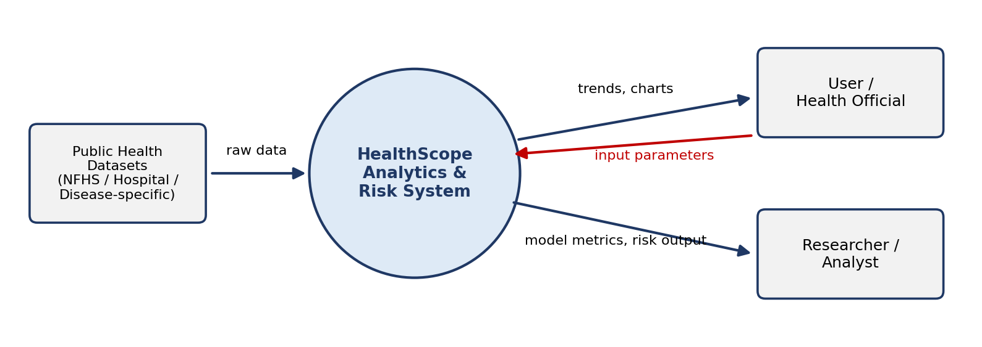
Fig. 4.2 DFD Level-0 (context diagram)
Fig. 4.3 expands the system into four processes – ingestion and preprocessing, EDA and feature engineering, model training and evaluation, and the dashboard with risk prediction – and four data stores: raw data, clean data, feature set and trained model.
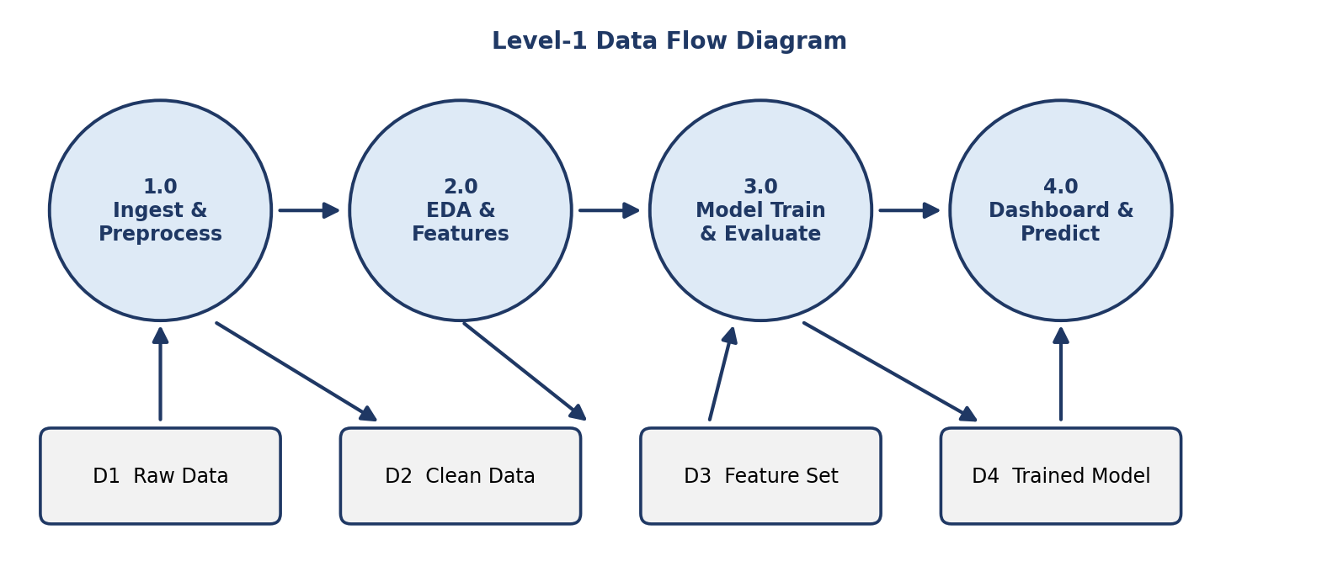
Fig. 4.3 DFD Level-1

CHAPTER 5
Design

5.1 Wireframes and Mock-ups
Before implementing the dashboard, simple wireframes were prepared for the three principal screens. The wireframes fix the position of filters, charts and result areas and ensure that every objective has a corresponding screen. The final screenshots of the implemented dashboard are given in Appendix A.

5.1.1 Health Trends Explorer
The first screen allows users to explore health indicators. A filter panel on the left lets the user choose a region, an indicator, an age group and a year. The main area shows a trend chart, a regional comparison chart, a correlation heatmap and summary statistics, all of which update when a filter changes.
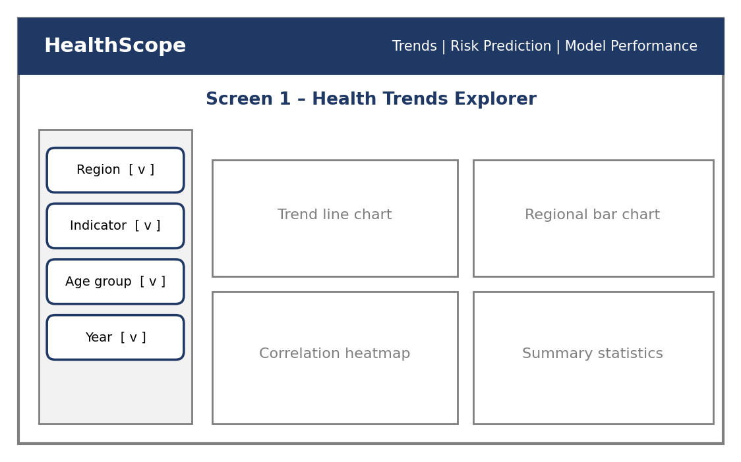
Fig. 5.1 Wireframe – Health Trends Explorer

5.1.2 Risk Prediction
The second screen accepts health parameters such as age, BMI, blood pressure, haemoglobin and place of residence. On pressing the Predict Risk button, the saved model returns the predicted risk class, the associated probability and the factors that contribute most to the result. A disclaimer clarifies that the output is a risk indicator and not a diagnosis.
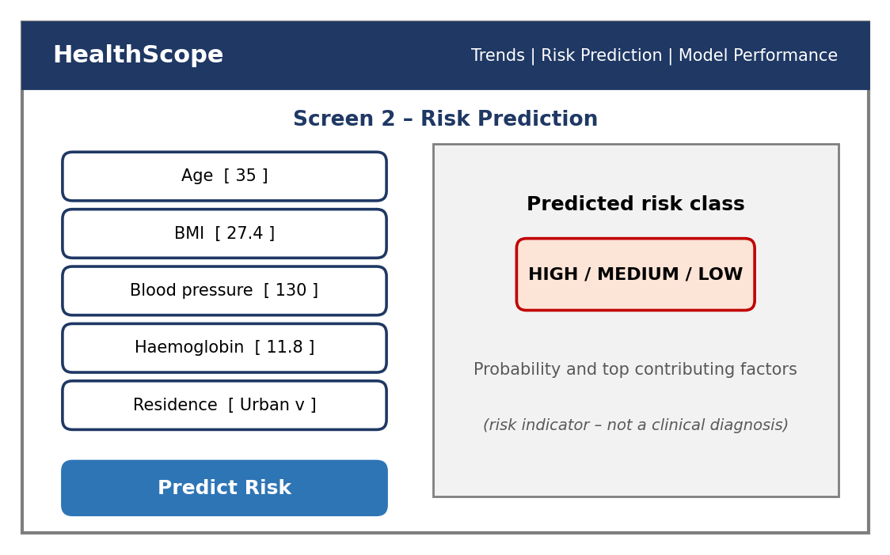
Fig. 5.2 Wireframe – Risk Prediction

5.1.3 Model Performance
The third screen supports the comparison of the five models. It shows a bar chart of accuracy, precision, recall and F1-score for every model and the confusion matrix of the selected model.
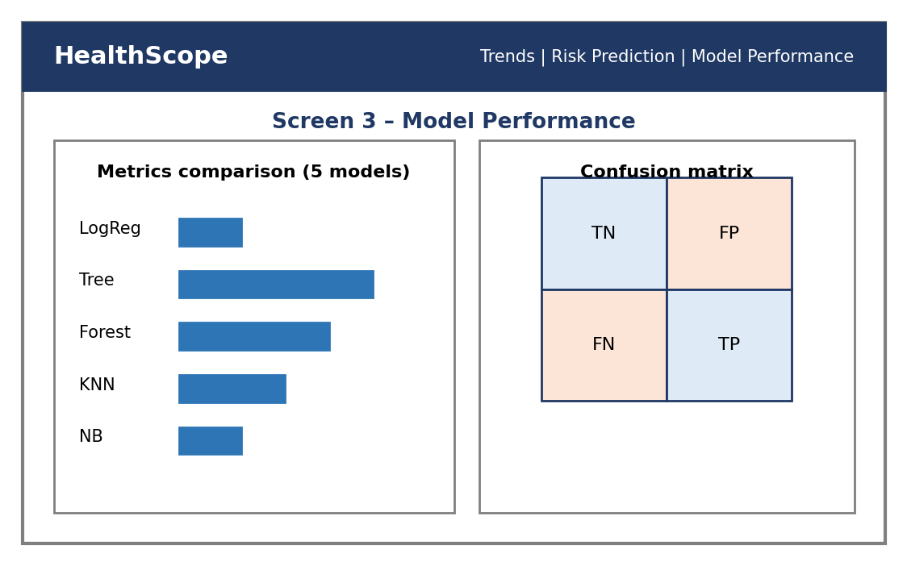
Fig. 5.3 Wireframe – Model Performance

5.2 ER Diagram / Database Schema
Although the current implementation stores data as files, a logical schema was designed so that the same structure can be moved to a relational database without change. Fig. 5.4 shows the five entities of the schema and the relationships among them.
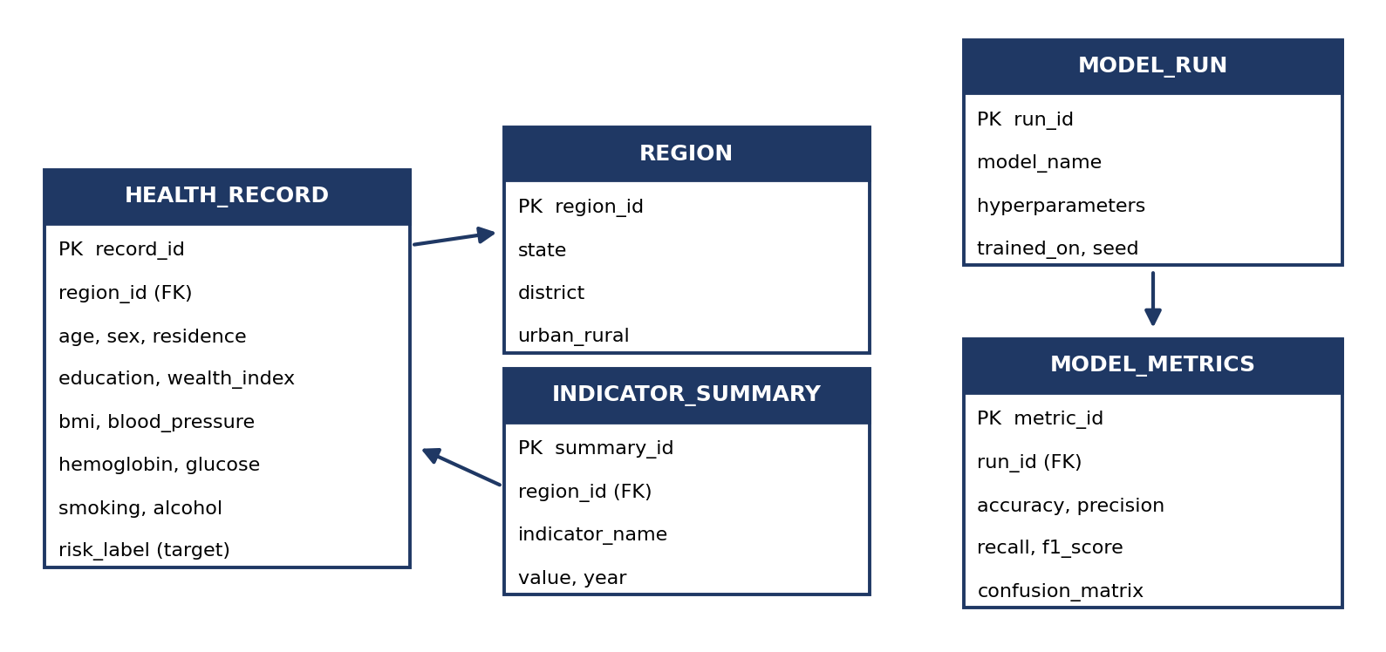
Fig. 5.4 Logical database schema (ER diagram)
Table 5.1 Description of schema entities
Entity | Description
HEALTH_RECORD | One row per surveyed person, household or admission, containing demographic fields, health indicators and the target risk label.
REGION | State, district and urban/rural classification; referenced by health records and indicator summaries through region_id.
INDICATOR_SUMMARY | Pre-aggregated indicator values by region and year, used by the Health Trends Explorer for fast chart rendering.
MODEL_RUN | One row per training run: model name, hyper-parameters, random seed and training data used.
MODEL_METRICS | Accuracy, precision, recall, F1-score and confusion matrix produced by each model run (one-to-one with MODEL_RUN).

5.3 Pipeline Flowchart
Fig. 5.5 presents the sequence of operations executed by the processing and modelling layers. The same flow is repeated for each of the five models so that the comparison is fair.
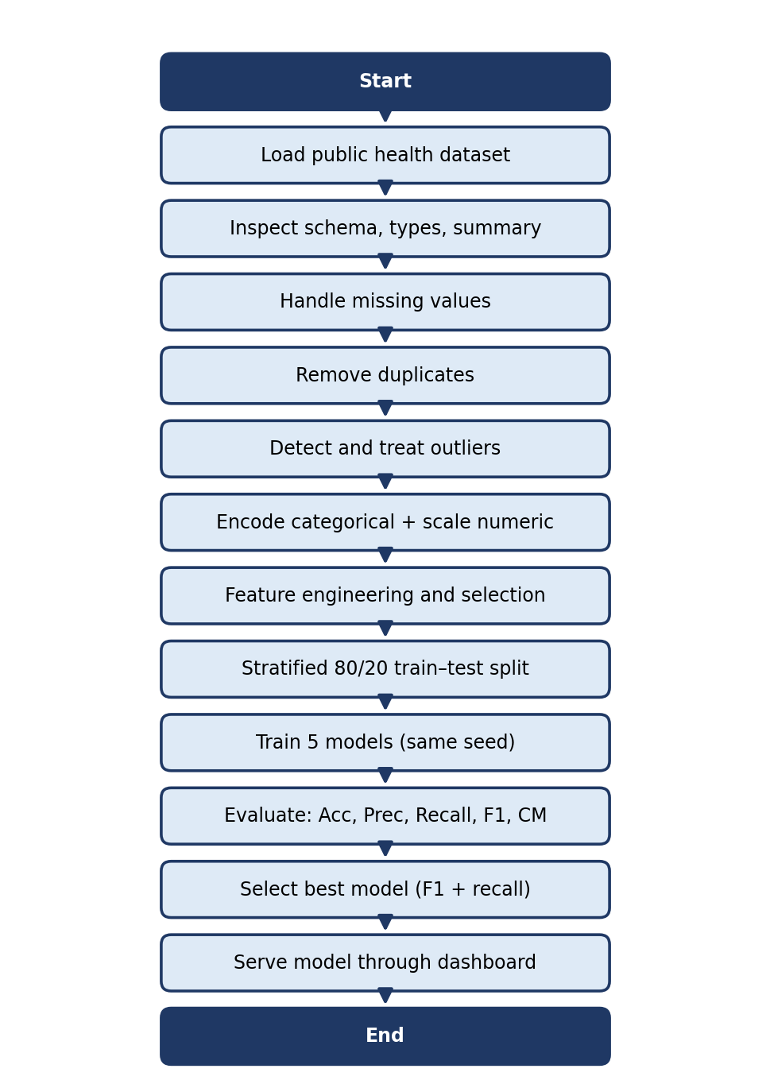
Fig. 5.5 Flowchart of the data-processing and modelling pipeline

CHAPTER 6
Implementation

6.1 Module-wise Implementation
The project was divided into four modules. Each of the first three modules was developed primarily by one team member, and the fourth module was integrated jointly by the entire team. Every member understands and can explain every module.
Table 6.1 Modules of HealthScope
Module | Purpose | Input → Output | Developed by
1. Data Ingestion & Preprocessing | Ingest, clean and validate data | Raw datasets → clean dataset | Siril Punna
2. EDA & Feature Engineering | Find patterns and engineer features | Clean data → feature set | D. Dinesh Kumar
3. ML Modelling & Evaluation | Train and compare five models | Features → metrics and best model | D. Srivatsav Reddy
4. Dashboard & Risk Prediction | Visualise trends and predict risk | User inputs + model → risk output | All team members

6.2 Data Understanding, Ingestion and Preprocessing (Module 1)

6.2.1 Data sources
HealthScope is designed around three candidate categories of public data, all of which share demographic and health-indicator fields that can be used for risk classification.
Table 6.2 Candidate data sources
Source | Content
National Family Health Survey (NFHS) | Demographic, household and health indicators across regions: age, sex, education, wealth index, nutrition and non-communicable disease measures.
Hospital admission datasets | Admission records, diagnoses and patient demographics.
Disease-specific datasets | Clinical risk factors and outcome labels for a single disease.

The selected dataset for the final experiments is summarised below.
Table 6.3 Summary of the selected dataset
Property | Value
Dataset name and source URL | [to be filled – e.g., NFHS extract / disease dataset]
Number of records (rows) | [to be filled]
Number of features (columns) | [to be filled]
Target variable | Health-risk class (derived from the dataset’s outcome field)
Class distribution (low / high risk) | [to be filled after class-balance check]

6.2.2 Preprocessing stages
Seven preprocessing stages are applied in sequence. Each stage is implemented as a function so that it can be tested separately.
- Ingestion and schema validation – the file is loaded with Pandas; column names, data types and expected ranges are checked and a data-quality report is printed.
- Missing-value handling – the percentage of missing values per feature is profiled. Numerical features are imputed with the median and categorical features with the most frequent category; features with an excessive share of missing values are dropped.
- Duplicate detection – exact duplicate records are identified and removed so that no observation is counted twice in training and testing.
- Outlier analysis – box plots and the inter-quartile range (IQR) rule are used to identify implausible values, which are capped or removed depending on whether they are valid extreme observations or data-entry errors.
- Encoding – categorical fields are converted to numerical form using one-hot encoding (nominal) or ordinal encoding (ordered categories).
- Scaling and normalisation – numerical features are standardised, which is essential for distance-based KNN and for the regularised Logistic Regression.
- Target class balance check – the proportion of each risk class is inspected; if the classes are imbalanced, a stratified split is used and F1-score and recall are prioritised over plain accuracy.
import pandas as pd
from sklearn.impute import SimpleImputer
from sklearn.preprocessing import StandardScaler, OneHotEncoder
from sklearn.compose import ColumnTransformer
from sklearn.pipeline import Pipeline

df = pd.read_csv("data/raw/health_data.csv")
df = df.drop_duplicates() # duplicate removal

# IQR rule: cap extreme values for numeric features
def cap_outliers(s):
q1, q3 = s.quantile([0.25, 0.75])
iqr = q3 - q1
return s.clip(q1 - 1.5 * iqr, q3 + 1.5 * iqr)

num_cols = df.select_dtypes("number").columns.drop("risk_label")
cat_cols = df.select_dtypes("object").columns
df[num_cols] = df[num_cols].apply(cap_outliers)

preprocessor = ColumnTransformer([
("num", Pipeline([("imp", SimpleImputer(strategy="median")),
("sc", StandardScaler())]), num_cols),
("cat", Pipeline([("imp", SimpleImputer(strategy="most_frequent")),
("oh", OneHotEncoder(handle_unknown="ignore"))]), cat_cols)])

The ColumnTransformer object defined above is reused unchanged for training and for the dashboard, which guarantees that a value entered by the user is transformed in exactly the same way as the training data.

6.3 Exploratory Data Analysis and Feature Engineering (Module 2)
Exploratory data analysis (EDA) was performed to understand the data before modelling. The following analyses are carried out and each of them is used to guide a modelling decision:
- Distributions and summary statistics – histograms and descriptive statistics reveal skewness and scale differences among the features.
- Correlation heatmap – shows the strength of linear association between health indicators and with the target, and helps to detect redundant, highly correlated features.
- Outlier box plots – identify extreme values that may distort distance-based and linear models.
- Demographic and regional trend plots – reveal how risk indicators vary with age group, sex, residence and region; these plots also feed the Health Trends Explorer.
- Target class balance – decides whether stratified sampling and F1/recall-oriented evaluation are required.
Feature engineering then converts the cleaned data into a set of informative inputs. Typical engineered features include age groups, BMI categories, combinations of related indicators and one-hot encoded categories. Feature selection combines correlation analysis with feature-importance values from Random Forest so that only the most informative demographic and health indicators are retained.

6.4 Model Building and Evaluation (Module 3)

6.4.1 Algorithms used
Five classifiers were selected so that the study covers linear, tree-based, distance-based and probabilistic approaches. Table 6.4 explains the reason for choosing each algorithm and the key parameters considered.
Table 6.4 Algorithms used in HealthScope
Algorithm | Why chosen | Key parameters | Category
Logistic Regression | Simple, interpretable baseline for risk classification; coefficients show the direction and size of each factor’s effect | Regularisation strength C, solver, max_iter | Linear
Decision Tree | Captures non-linear patterns and produces human-readable rules | max_depth, min_samples_split | Tree-based
Random Forest | Ensemble of trees; robust to noise and overfitting; ranks feature importance | n_estimators, max_depth | Tree ensemble
K-Nearest Neighbours | Distance-based method that classifies a case by its most similar neighbours | k (neighbours), distance metric | Distance-based
Naïve Bayes | Fast probabilistic model that provides a useful contrast to the other four | var_smoothing (Gaussian NB) | Probabilistic

6.4.2 Training set-up
- Feature selection – demographic and health indicators chosen using correlation and feature importance.
- Preprocessing pipeline – ingestion, cleaning, duplicate and outlier treatment, encoding and scaling.
- Data splitting – an 80/20 stratified train–test split, with cross-validation used for model comparison.
- Configuration – the same split and the same random seed are used for all five models so that the comparison is fair.
from sklearn.model_selection import train_test_split, cross_val_score
from sklearn.linear_model import LogisticRegression
from sklearn.tree import DecisionTreeClassifier
from sklearn.ensemble import RandomForestClassifier
from sklearn.neighbors import KNeighborsClassifier
from sklearn.naive_bayes import GaussianNB
from sklearn.metrics import classification_report, confusion_matrix

X, y = df.drop(columns="risk_label"), df["risk_label"]
X_train, X_test, y_train, y_test = train_test_split(
X, y, test_size=0.20, stratify=y, random_state=42)

models = {
"LogReg": LogisticRegression(max_iter=1000),
"Tree": DecisionTreeClassifier(random_state=42),
"Forest": RandomForestClassifier(random_state=42),
"KNN": KNeighborsClassifier(),
"NaiveBayes": GaussianNB()}

for name, m in models.items():
pipe = Pipeline([("prep", preprocessor), ("model", m)])
cv = cross_val_score(pipe, X_train, y_train, cv=5, scoring="f1")
pipe.fit(X_train, y_train)
print(name, "CV-F1 =", cv.mean().round(3))
print(classification_report(y_test, pipe.predict(X_test)))
print(confusion_matrix(y_test, pipe.predict(X_test)))

6.4.3 Selection of the final model
The final model is selected using the best F1-score and recall on the test data, balanced with interpretability and speed. Recall is given particular weight because, in a risk-screening setting, a false negative (a high-risk case that is missed) is more costly than a false alarm. The selected pipeline is saved with Joblib so that it can be loaded by the dashboard.

6.5 Dashboard Logic (Front-end) (Module 4)
The dashboard is a single Streamlit script organised into three pages selectable from a sidebar. State management is handled by Streamlit itself: every widget value is stored in the session and the script re-runs from top to bottom when a value changes. Expensive operations such as loading the data and the model are cached using st.cache_data and st.cache_resource so that the dashboard remains responsive.
import streamlit as st, pandas as pd, joblib, plotly.express as px

@st.cache_data
def load_data(): return pd.read_csv("data/processed/clean.csv")
@st.cache_resource
def load_model(): return joblib.load("models/best_model.joblib")

page = st.sidebar.radio("Page", ["Trends", "Risk Prediction", "Model Performance"])
df, model = load_data(), load_model()

if page == "Trends":
region = st.sidebar.selectbox("Region", sorted(df["region"].unique()))
ind = st.sidebar.selectbox("Indicator", ["bmi", "blood_pressure", "hemoglobin"])
view = df[df["region"] == region]
st.plotly_chart(px.histogram(view, x=ind, color="risk_label"))

elif page == "Risk Prediction":
age = st.number_input("Age", 1, 100, 35)
bmi = st.number_input("BMI", 10.0, 60.0, 27.4)
bp = st.number_input("Blood pressure", 60, 220, 130)
if st.button("Predict Risk"):
x = pd.DataFrame([{"age": age, "bmi": bmi, "blood_pressure": bp}])
st.success(f"Predicted risk class: {model.predict(x)[0]}")
st.caption("Risk indicator only – not a clinical diagnosis.")

The code above is shown in simplified form to explain the structure of the dashboard; the complete script additionally handles all input fields, the probability display and the confusion-matrix page.

6.6 Data Connectivity and API Integration
The dashboard connects to the stored artefacts – the processed dataset, the trained model and the metrics table – through simple file reads. No external web service is called at run time, which keeps the system independent of network availability. Dataset acquisition from public portals (NFHS and open-data portals) is performed during the data-ingestion stage, before the dashboard is started. Integration with live open-health APIs is planned for future versions (Chapter 11).

6.7 Access Control, Authentication and Data Privacy
The current version is intended for local use by the project team, examiners and invited users, and therefore does not implement user accounts. Privacy is protected by design: only public, anonymised datasets are used, no personally identifiable information is collected, and values typed on the Risk Prediction page are processed in memory and are not stored. Role-based access for health officials, researchers and the general public is included in the future scope.

CHAPTER 7
Features

7.1 List of Main Features
- Automated data ingestion with schema validation and a data-quality report.
- Missing-value, duplicate and outlier handling in a reusable preprocessing pipeline.
- Exploratory data analysis with distributions, correlation heatmap and box plots.
- Feature engineering and importance-based feature selection.
- Training and comparison of five machine-learning models on identical data splits.
- Evaluation using accuracy, precision, recall, F1-score and confusion matrix.
- Health Trends Explorer with region and demographic filters.
- Interactive health-risk prediction from user-supplied parameters.
- Model Performance page for side-by-side comparison of all models.

7.2 How Each Feature Works
Table 7.1 Feature descriptions – user perspective and technical description
Feature | User perspective | Technical description
Data ingestion and quality report | The user places a dataset in the data folder and runs the pipeline; a summary of rows, columns and quality issues is displayed. | Pandas reads the CSV, checks data types and ranges, and prints missing-value, duplicate and outlier counts.
Cleaning and preprocessing | No manual effort; the cleaned dataset is produced automatically. | A Scikit-learn ColumnTransformer applies imputation, encoding and scaling; outliers are capped using the IQR rule.
Exploratory analysis | Charts show how indicators are distributed and related. | Matplotlib/Seaborn/Plotly generate histograms, heatmaps and box plots from the clean dataset.
Model comparison | A table and chart show which model performs best. | Five pipelines are trained with the same seed and split; classification_report and confusion_matrix are computed for each.
Health Trends Explorer | The user selects a region, indicator and group and instantly sees the chart. | Streamlit select boxes filter the DataFrame; Plotly renders the filtered view.
Risk prediction | The user enters age, BMI, blood pressure and other fields and presses Predict Risk to receive a risk class. | The input is turned into a one-row DataFrame, passed through the saved pipeline and the predicted class is displayed.
Model Performance page | The user sees all metrics and the confusion matrix of the best model. | Metrics saved after training are read from file and plotted.

CHAPTER 8
Testing
Testing was carried out at three levels: functional testing of each pipeline stage, integration testing of the complete flow from raw data to dashboard, and performance testing of the machine-learning models. Postman testing, which is listed in the report format for web back-ends, is not applicable to HealthScope because the system exposes no REST API; the equivalent activity here is the validation of the dashboard inputs and outputs described in Section 8.1.

8.1 Functional Testing (Pipeline and Dashboard)
Each stage of the pipeline was tested using small sample files with known characteristics – for example, a file containing deliberately inserted null values and duplicate rows – and the output was checked against the expected result. On the dashboard, valid, boundary and invalid inputs were entered on the Risk Prediction page (for example an age of zero or a negative blood-pressure value) to confirm that the page either returns a valid risk class or displays a clear validation message.

8.2 Integration Testing
Integration testing confirmed that the modules cooperate correctly: the output of Module 1 (clean dataset) is accepted by Module 2, the feature set produced by Module 2 is accepted by Module 3, and the model saved by Module 3 is loaded and used by Module 4. The complete flow was executed end to end on a fresh environment to verify that no step depends on variables left over in a notebook session.

8.3 Tools Used for Testing
- Jupyter / Google Colab – interactive execution and inspection of intermediate outputs.
- Pandas assertions – checks that no null or duplicate records remain after cleaning and that the schema matches expectations.
- Scikit-learn metrics and cross-validation – accuracy, precision, recall, F1-score, confusion matrix and k-fold validation.
- Streamlit – manual testing of widgets and the displayed output in the browser.

8.4 Test Cases and Results
Table 8.1 lists the representative test cases. The “Actual result” and “Status” columns are to be recorded after the final execution on the selected dataset.
Table 8.1 Test cases
Test ID | Test description | Expected result | Actual result | Status
TC-01 | Dataset ingestion | Data loads with the correct schema | [Record result] | [Pass / Fail]
TC-02 | Missing-value and duplicate handling | No nulls or duplicates remain | [Record result] | [Pass / Fail]
TC-03 | Outlier treatment | Values lie within the capped range | [Record result] | [Pass / Fail]
TC-04 | Training of all five models | Each model trains and predicts | [Record result] | [Pass / Fail]
TC-05 | Dashboard risk prediction | Valid risk output for the chosen inputs | [Record result] | [Pass / Fail]
TC-06 | Invalid dashboard input | Clear validation message, no crash | [Record result] | [Pass / Fail]
TC-07 | Trends filters | Charts update for every region/indicator choice | [Record result] | [Pass / Fail]

8.5 Validation Method and Evaluation Framework
Validation uses an 80/20 stratified train–test split together with 5-fold cross-validation on the training data for every model. The five evaluation metrics are defined below, where TP, TN, FP and FN denote true positives, true negatives, false positives and false negatives for the “high risk” class.
Table 8.2 Evaluation metrics
Metric | Formula | Meaning in HealthScope
Accuracy | (TP + TN) / (TP + TN + FP + FN) | Share of all predictions that are correct
Precision | TP / (TP + FP) | Correct share among cases predicted as at risk (low false alarms)
Recall | TP / (TP + FN) | Share of truly at-risk cases that are found (few missed cases)
F1-score | 2 × Precision × Recall / (Precision + Recall) | Balance between precision and recall
Confusion matrix | 2 × 2 table of TP, FP, FN, TN | Shows exactly which kinds of errors each model makes

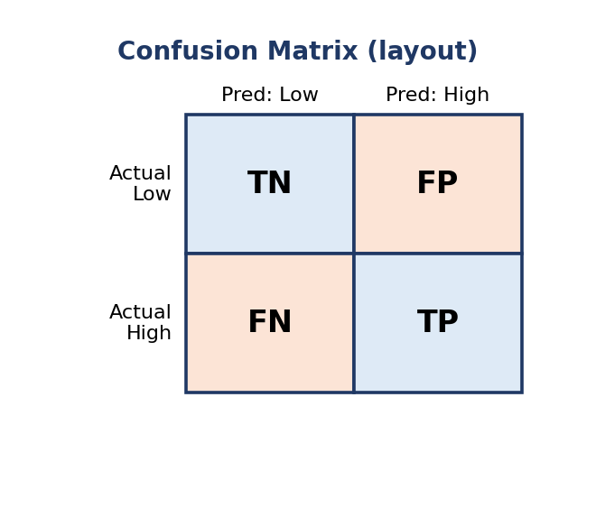
Fig. 8.1 Layout of the confusion matrix used for evaluation

8.6 Results and Performance Comparison
Table 8.3 compares the five models on the held-out test set. The best model is the one with the highest F1-score; recall is additionally checked to limit missed high-risk cases.
Table 8.3 Performance comparison of the five models
Model | Accuracy | Precision | Recall | F1-score
Logistic Regression | [ ] | [ ] | [ ] | [ ]
Decision Tree | [ ] | [ ] | [ ] | [ ]
Random Forest | [ ] | [ ] | [ ] | [ ]
K-Nearest Neighbours | [ ] | [ ] | [ ] | [ ]
Naïve Bayes | [ ] | [ ] | [ ] | [ ]

Best model: [model name] with an F1-score of [XX.X%].

8.6.1 Interpretation of results
- Precision versus recall – comparing the two shows whether a model produces more false alerts or more missed risks.
- Error analysis – false negatives (missed high-risk cases) are the costliest errors in a screening context, so models with a higher recall are preferred when their F1-scores are close.
- Key drivers – feature importance from Random Forest and the coefficients of Logistic Regression indicate which demographic and health indicators contribute most to risk.
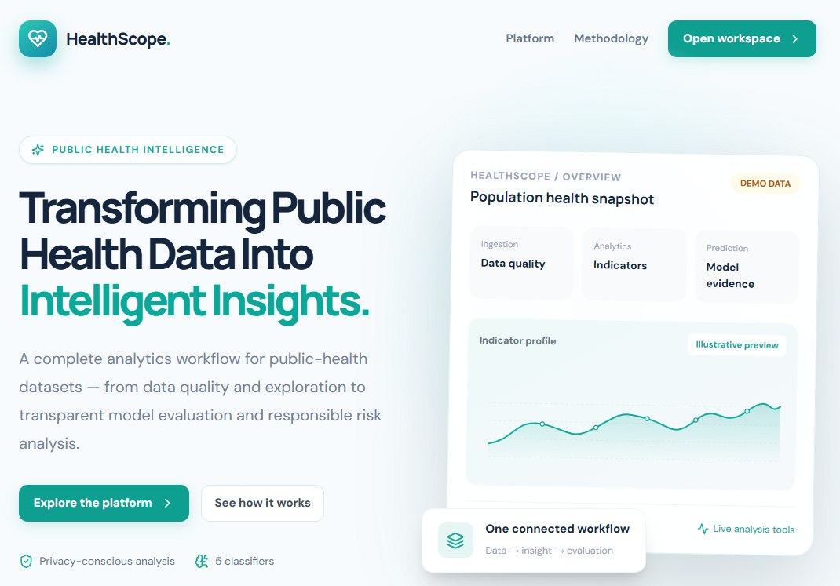

CHAPTER 9
Deployment

9.1 Steps to Deploy
The following steps install and run HealthScope on a new Windows machine.
- Install Python 3 and Git from their official websites.
- Clone the project repository from GitHub: git clone <repository-URL> and open the project folder.
- Create and activate a virtual environment: python -m venv venv followed by venv\Scripts\activate.
- Install the dependencies: pip install -r requirements.txt.
- Place the dataset in the data/raw folder.
- Run the pipeline notebooks (or script) in order: preprocessing → EDA and features → modelling. This creates the processed data, the saved model and the metrics file.
- Start the dashboard: streamlit run app.py.
- Open the displayed local address (by default http://localhost:8501) in a web browser.

9.2 Environment Configuration
Table 9.1 Environment configuration
Item | Configuration
Python version | Python 3.x (recorded in requirements.txt / README)
Dependencies | pandas, numpy, scikit-learn, matplotlib, seaborn, plotly, streamlit, joblib – installed from requirements.txt
Random seed | random_state = 42 for all splits and models
Folder structure | data/raw, data/processed, models, notebooks, app.py
Port | Streamlit default 8501 (configurable with --server.port)

9.3 Hosting
In the current version the dashboard is hosted locally: the Streamlit server runs on the developer’s machine and is accessed through the browser. The notebooks may also be executed on Google Colab. Because the dashboard is a standard Streamlit application, it can later be hosted on a public platform such as Streamlit Community Cloud or a cloud virtual machine without code changes; this is part of the future scope.
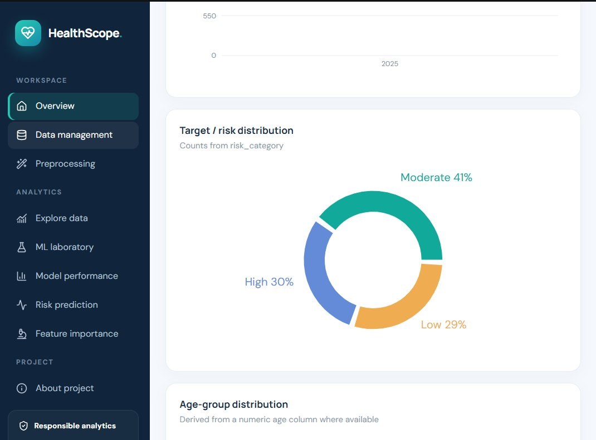

CHAPTER 10
Challenges & Limitations

10.1 Issues Faced During Development
- Missing values and outliers in the public datasets threatened to bias the models.
- Imbalanced risk classes – the number of high-risk cases was much smaller than the number of low-risk cases, which makes plain accuracy misleading.
- Choosing among five models – each model has different strengths, so a fair and objective selection criterion was needed.
- Consistent preprocessing between training and the dashboard, so that user inputs are transformed exactly as the training data.
- Team coordination – three members developed different modules at the same time and had to merge their work without conflicts.

10.2 Solutions Applied
Table 10.1 Challenges and solutions
Challenge | Solution applied
Missing values and outliers | Median/mode imputation and IQR-based outlier analysis and capping
Imbalanced risk classes | Stratified train–test split; F1-score and recall used as primary metrics
Choosing among five models | All models compared on the same split, seed and common metrics
Training/prediction mismatch | Single Scikit-learn Pipeline saved and reused by the dashboard
Team coordination | GitHub branches per module, regular merges and shared documentation

10.3 Current Limitations or Known Bugs
- The system relies on public datasets; survey data may be self-reported and may contain reporting bias.
- Predictions are risk indicators, not clinical diagnoses, and must not be used for treatment decisions.
- There are no live hospital or wearable data feeds; the data is analysed in batch mode.
- The dashboard has no user authentication or role-based access in the current version.
- Only classical machine-learning models are used; deep-learning and big-data (Spark) models are out of scope.

CHAPTER 11
Future Enhancements

11.1 Planned Features
Table 11.1 Planned enhancements
Area | Planned enhancement
Improve performance | Hyper-parameter tuning (grid/random search) and boosting or other ensemble models such as Gradient Boosting and XGBoost/LightGBM.
Expand data and features | Include more NFHS rounds, more diseases and more regions; add temporal analysis of trends over survey rounds.
Deploy and build an interface | Public web dashboard with role-based access for officials, researchers and citizens, and automated alerts when risk thresholds are crossed.
Scale and secure | Cloud deployment, stronger data-privacy controls and Apache Spark for very large datasets.

11.2 Possible Integrations and Optimisations
- Open health-data APIs (WHO, data.gov and national survey portals) to refresh the data automatically.
- PostgreSQL and a data lake for persistent storage of large datasets, with Redis for caching frequently requested dashboard queries.
- Power BI integration as an alternative reporting front-end for administrators.
- Explainable AI techniques such as SHAP values to explain each individual prediction.
- Automated pipelines (CI/CD) to re-train and re-evaluate models whenever new data is added.

11.3 Real-World Applications
- Public-health monitoring by health officials.
- Early risk screening for communities.
- Policy planning and resource allocation.
- Potential adopters: health departments, NGOs and researchers.

CHAPTER 12
Conclusion

12.1 Summary of the Project
HealthScope – A Full-Lifecycle Public Health Analytics & Risk Dashboard – is an end-to-end system built in Python on public datasets such as the National Family Health Survey. It brings together data ingestion, cleaning, exploratory analysis, feature engineering, machine-learning risk prediction and interactive visualisation in a single, reproducible platform. Five classifiers – Logistic Regression, Decision Tree, Random Forest, K-Nearest Neighbours and Naïve Bayes – are trained on identical data and compared on accuracy, precision, recall, F1-score and confusion matrix. An interactive Streamlit dashboard turns the results into health trends, risk factors and risk predictions that support data-driven decision-making.

12.2 What Was Achieved
Table 12.1 Objectives and outcomes
No. | Objective | Outcome
1 | Design an end-to-end pipeline for ingestion, cleaning, EDA and feature engineering | Achieved – modular seven-stage preprocessing and EDA pipeline implemented
2 | Train and compare five machine-learning models | Achieved – five models trained on the same split and seed
3 | Evaluate every model using five metrics | Achieved – accuracy, precision, recall, F1-score and confusion matrix computed
4 | Develop an interactive dashboard | Achieved – Trends Explorer, Risk Prediction and Model Performance pages

All four objectives were addressed. In the final outcome, five models are compared on five evaluation metrics inside one end-to-end dashboard platform.

12.3 Skills Learned During Development
- Practical data engineering: ingestion, cleaning, missing-value handling, duplicate and outlier treatment.
- Exploratory analysis and feature engineering on real-world health data.
- Implementing and comparing multiple machine-learning algorithms with Scikit-learn and interpreting metrics for imbalanced data.
- Building interactive dashboards with Streamlit and Plotly.
- Collaboration using Git and GitHub, modular design and technical documentation, along with awareness of the ethical aspects of health analytics – privacy, fairness and the difference between risk indication and diagnosis.

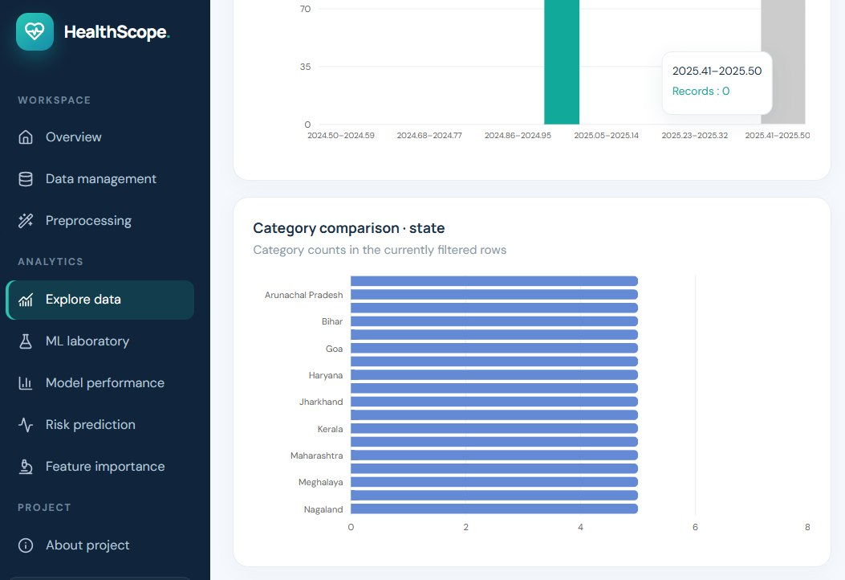

- \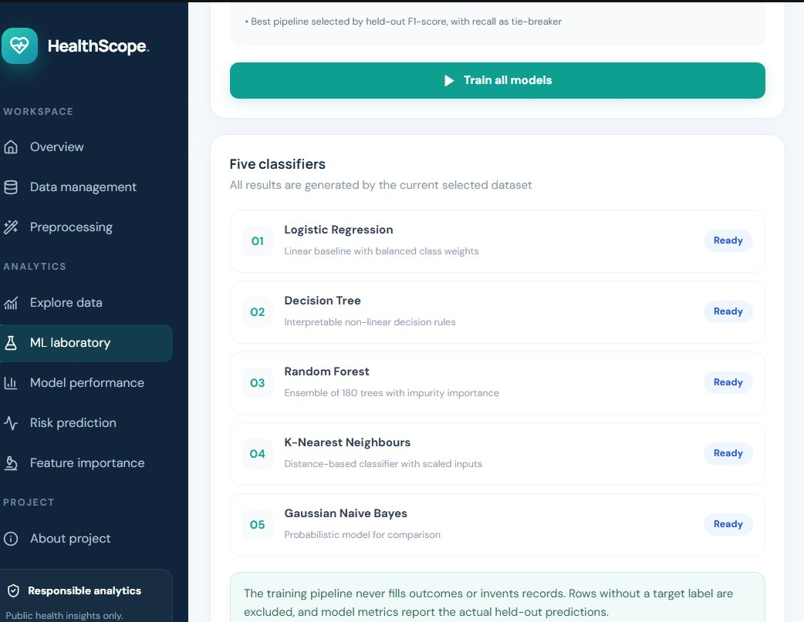

CHAPTER 13
References
[1] Wang, Song, and Bi, “Optimizing public health management with predictive analytics: Leveraging the power of random forest,” 2025.
[2] Chen and Long, “Predicting arthritis risk with machine learning: Insights from the 2023 National Health Interview Survey data,” 2025.
[3] Liu, Krentz, Lu, and Curcin, “Machine learning based prediction models for cardiovascular disease risk using electronic health records data: Systematic review and meta-analysis,” 2025.
[4] Dhanda et al., “Advancement in public health through machine learning: A narrative review of opportunities and ethical considerations,” 2025.
[5] International Institute for Population Sciences, “National Family Health Survey (NFHS),” [Online]. Available: http://rchiips.org/nfhs
[6] F. Pedregosa et al., “Scikit-learn: Machine learning in Python,” J. Mach. Learn. Res., vol. 12, pp. 2825–2830, 2011.
[7] W. McKinney, “Data structures for statistical computing in Python,” in Proc. 9th Python in Science Conf., 2010, pp. 56–61.
[8] L. Breiman, “Random forests,” Machine Learning, vol. 45, no. 1, pp. 5–32, 2001.
[9] Streamlit Inc., “Streamlit documentation,” [Online]. Available: https://docs.streamlit.io
[10] Plotly Technologies Inc., “Plotly Python graphing library,” [Online]. Available: https://plotly.com/python/

Fig. A.3 Model Performance – compare accuracy, precision, recall, F1-score and confusion matrix.

Appendix B – Sample Code Snippets
The key code segments are presented in Chapter 6 (preprocessing pipeline, model training and the dashboard script). The following snippet shows how the best model is saved and reloaded.
import joblib
best = max(results, key=lambda r: r["f1"]) # highest F1-score
joblib.dump(best["pipeline"], "models/best_model.joblib")

model = joblib.load("models/best_model.joblib") # in the dashboard
model.predict(user_input_df)

Appendix C – Installation and Set-up Instructions
- Install Python 3 (python.org) and Git (git-scm.com).
- Run git clone <repository-URL> and cd HealthScope.
- Run python -m venv venv and activate it with venv\Scripts\activate (Windows) or source venv/bin/activate (Linux/macOS).
- Run pip install -r requirements.txt.
- Copy the dataset into data/raw/.
- Execute the notebooks in the order 01_preprocessing, 02_eda_features, 03_modelling.
- Run streamlit run app.py and open http://localhost:8501.

Appendix D – User Manual
- Open the dashboard in a web browser and choose a page from the left sidebar.
- Trends: select a region, indicator, age group and year; the charts update automatically. Hover over a chart for exact values.
- Risk Prediction: type the requested health parameters, press Predict Risk, and read the predicted risk class and the contributing factors. Remember that the result is a risk indicator, not a diagnosis.
- Model Performance: review the metrics table and the confusion matrix to see how each model performed.

Appendix F – Team Contribution
Table F.1 Contribution of each team member
Reg. No. | Name | Contribution / modules handled
2420030300 | Siril Punna | Data ingestion and preprocessing module; data and methodology report sections
2420030169 | D. Dinesh Kumar | EDA and feature engineering module; visualisations and report sections
2420030320 | D. Srivatsav Reddy | ML modelling and evaluation module; dashboard integration and results
Testing and deployment


